Technical Design Document

## Section 1 – List of Features Captured from GDD

* 1. **List of Features Based on the Game Design Document:**
* First Person
* Game Object including:

3D objects  
o Character and zombies  
o Weapon  
o Park

* Windows platform deployed
* Background Story
* Audio and Sound Effects
* One type of zombies
* Realistic AI of zombies
* Scoring system
* Comprehensive/informative HUD

## Section 2 – Choice of Game Engine

The game engine that has been chosen is Unity. Unity is a cross-platform game engine developed by Unity Technologies, first announced and released in June 2005 at Apple Inc.'s Worldwide Developers Conference as a Mac OS X-exclusive game engine:

* Animation
* AI
* Audio system
* Physics support with physics assets
*  Rendering

## Section 3 – Schedule:

The schedule for the development of the game is shown below:

|  |  |  |  |
| --- | --- | --- | --- |
| **Task** | Week 1 | Week 2 | Week 3 |
|  |  |  |  |
|  |  |  |  |
| Game Design Document |  |  |  |
| Technical Design Document |  |  |  |
| Create Levels |  |  |  |
| Create Characters |  |  |  |
| Create Objects and Weapons |  |  |  |
| Create Triggers and Events |  |  |  |
| Code Development |  |  |  |
| Testing |  |  |  |
| Evaluation |  |  |  |
| Create journal of design and implementation ideas |  |  |  |
| Create Walk Through of Game |  |  |  |
| Create Manual |  |  |  |
| Create Group Report |  |  |  |

* Every member of the group will contribute to every task.
* Each task will have a lead group member.
* This lead group member will be in charge of that particular task being done and will contribute to that task more than the other group members.
* The lead group members will be based on team members strengths and previous knowledge.

## Section 4 – High-level Diagrams to Illustrate Software Design

**4.1 Implementation Diagram:**

•  The implementation diagram illustrates the flow of the different stages of the creation of the game

•  It also includes what weeks each stage will take place at

•  This diagram is displayed in Figure 5

Concept Development and Design (Week 1-2)

Testing (Week 12- 1.

Evaluation (Week 12- 13)

Level and 3D Model Design (Week 1)

Documentation (Week 1-13)

Deploy Final Demo (Week 13)

Coding and Scripting

(Week 1-3)

Testing (Week 3)

Evaluation (Week 3)

Documentation (Week 3)

Deploy Final Demo (Week 3)

## Section 5 – 3D Objects, Terrain, & Scene Management

**5.1 Terrain:**

* Roads
* Chalets
* Trees
* Sky
* Mountains
* Borders

## Section 6 – Collision Detection, Physics & Interaction

* 1. **Collision Detection:**
* This is where there will need to be detection of the intersection of two or more objects within the game
* Characters cannot walk through objects – objects must remain solid
* Characters will need to jump over items or walk round items as characters cannot walk through the items
* Collision detection will be needed for when:
* Characters hit the zombies with weapons or their fists
* Zombies and characters collide
* Zombies hitting into walls, doors or other objects  
  1. **Physics:**
* This is the component that makes the game real
* Objects and players must react to player input and player decision (e.g. picking up ammo)
* Must be realistic (how it would be in real life)
* Gravity
* Physics will be needed for:
* Picking up items
* To enforce physics in the game:
* Unity can be used with physics assets implemented onto objects using RigidBody.
  1. **Interaction:**
* This is how characters interact with the game world
* Interaction with objects/items:
* Picking up weapons
* Interacting with zombies
* Zombie’s interaction:
* Zombies remain following a path unless triggered by characters presence
* Once triggered, zombies path changes to follow character until it cannot see the character anymore
* To enforce interaction in the game:
* Unity can be used with triggers

## Section 7 –Artificial Intelligence

**7.1 Artificial Intelligence:**

The zombie’s path will use AI

* They will loop around until they see the playable character.
* When they have seen the playable character then they will continue to go after them.

## Section 8 – Audio & Visual Effects

**8.1 Audio Effects:**

* Free sounds from the internet

## Section 9 – Delivery Platform & Hardware/Software Requirements

**9.1 Delivery Platform:**

• PC Windows platform

* 1. **Hardware Requirements**:
* Dual core processor
* 1GBRAM
* Keyboard
* Mouse
* Monitor
* Speakers
* Hard drive
* Graphics
* CD Drive/USB
  1. **Software Requirements:**
* Windows XP, Windows Vista or Windows 7

## Section 10: Class Diagrams:

1- healthbar.cs:

This class showcases the health bar on the screen as it changes.

2- playerHealth.cs:

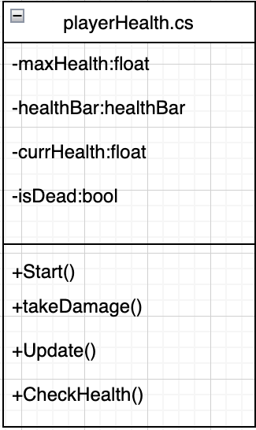

3- Spawnerr.cs:

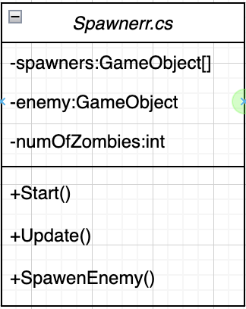

4- LookAtCamera.cs:

This class follows the player wherever they go.

5- Zombies.cs:

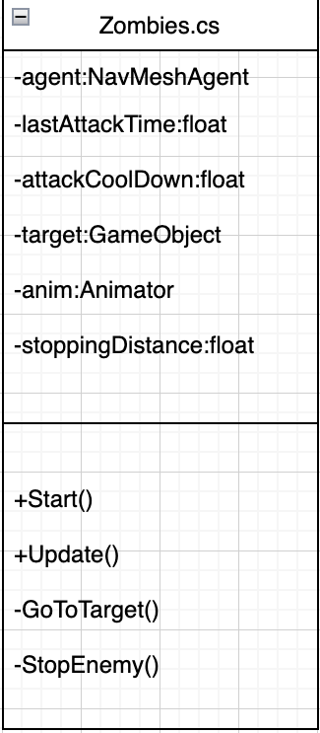

## Section 11: Flowchart:

